Addition – Year 3

|  |  |
| --- | --- |
| National Curriculum Key Skills | Key vocabulary |
| * Add 2-digit numbers mentally, including those exceeding 100 * Add a 3-digit number and ones mentally   (e.g. 127 + 6 )   * Add a 3-digit number and tens mentally   (e.g. 239 + 40 )   * Add a 3-digit number and hundreds mentally   (e.g. 235 + 300 )   * Continue to practise a wide range of mental addition strategies, i.e. number bonds, adding the nearest multiple of 10,100,1000 and adjusting, using near doubles, partitioning and recombining * Estimate and use the inverse to check answers * Solve problems, including missing number problems, using number facts, place value and more complex addition. | hundreds  tens  ones  expanded  compact  column  rename  regroup  partition  addition  carry  digits |

* Introduce the expanded column method first using manipulatives first.



Add the ones first in preparation for the compact method.

* Then introduce addition with renaming using the compact method with manipulatives first. Show how to rename, with partitioning.

 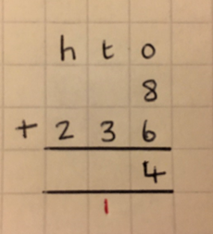

Add the ones first. Carry the numbers directly **below** the next number.

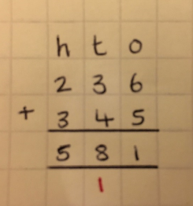

* Continue to use bar modelling as a visual model to solve addition calculations and word problems**.**

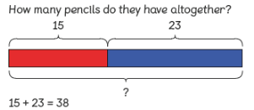

Addition – Year 4

|  |  |
| --- | --- |
| National Curriculum Key Skills | Key vocabulary |
| * Add numbers with up to 4 digits using the formal written methods of columnar addition. * Estimate and use inverse operations to check answers to a calculation * Solve addition two-step problems in contexts, deciding which operations and methods to use and why. | thousands  hundreds  tens  ones  expanded  compact  column  rename  regroup  addition  carry  digits |

* Begin with using the standard column method without renaming. Use concrete materials first then move onto a pictorial representation.

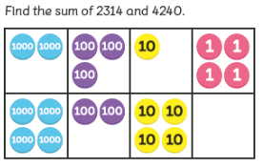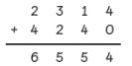

* Then re-introduce the column method with renaming (from Y3) but using up to 4-digit numbers.

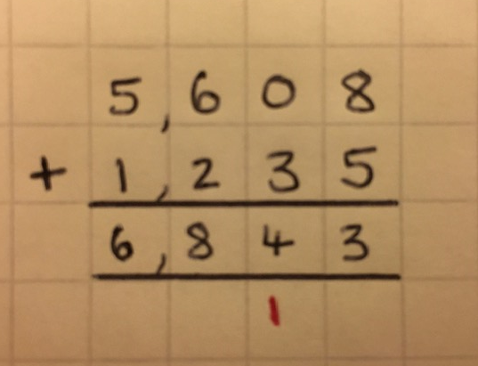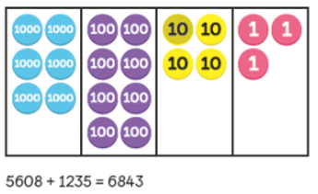

When renaming, the number is carried directly **below** the next number.  
Reinforce correct place value by reminding pupils the actual value is **6 hundreds** add   
2 **hundreds**, not **6 add 2**, for example.

* Continue to use bar modelling as a visual model when problem solving.

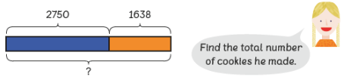

Addition – Year 5

|  |  |  |
| --- | --- | --- |
| National Curriculum Key Skills | Key vocabulary | |
| * Add numbers mentally with increasingly large numbers, using and practising a range of mental strategies i.e., add the nearest multiple of 10,100, 1000 and adjust, use near doubles, inverse, partitioning, recombining and using number bonds * Use rounding to check answers and accuracy * Solve multi-step problems in contexts, deciding which operations and methods to use and why * Add numbers with more than 4 digits using formal written method of columnar addition. | ten thousands  thousands  hundreds  tens  ones  expanded  compact  column | carry  digits  decimal  decimal point  tenths  hundredths  thousandths  rename  regroup  addition |

Pupils will add numbers with more than four digits but within 1,000,000.

* Use the standard column method, including renaming. Continue to use pictorial representations. When renaming, the number is carried directly **below** the next number.

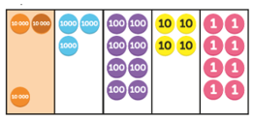 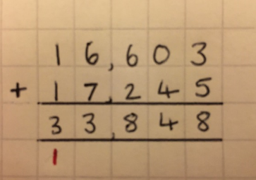

* When adding decimal numbers, use place value counters and pictorial representations.

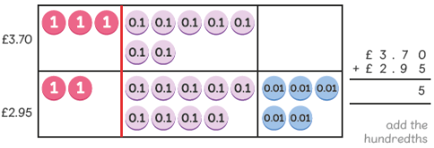

Pupils should be able to add more than two values, carefully aligning place value columns. Pupils should understand the place value of tenths and hundredths and use this to align numbers with different numbers of decimal places.

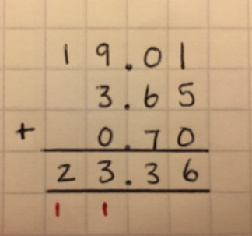

* Continue to use bar modelling as a visual model when problem solving.

Addition – Year 6

|  |  |  |
| --- | --- | --- |
| National Curriculum Key Skills | Key vocabulary | |
| * Perform mental calculations, including with mixed operations and large numbers, using and practising a range of mental strategies * Solve multi-step problems in contexts, deciding which operations and methods to use and why * Use estimation to check answers to calculations and determine, in the context of the problem, levels of accuracy * Children understand how to add mentally with larger numbers and calculations of increasing complexity. | ten thousands  thousands  hundreds  tens  ones  expanded  compact  column | carry  digits  decimal  decimal point  tenths  hundredths  thousandths  rename  regroup  addition |

Pupils will add several numbers of increasing complexity (including money and measures).

* Tenths, hundredths and thousandths should be correctly aligned, with the decimal point lined up vertically including in the answer row.
* Zeros will be added into any empty decimal places, to show there is no value to add.
* When renaming, the number is carried directly **below** the next number.
* Numbers could be ordered from largest to smallest in the equation.
* Adding several numbers with more than 4 digits.

