Division – Year 3
National Curriculum Key Skills | Key vocabulary
- Recall and use multiplication and division facts for the 2, 3, 4, 5, 8 and 10 multiplication tables  - Write and calculate mathematical statements for division using the multiplication tables that they know, including for two-digit numbers divided by one-digit numbers, using mental and progressing to formal written methods  - solve problems, including missing number problems | group  groups of  equal  lots of  divide  divided by  divided into  division | grouping  left  left over  inverse  short division  remainder  tens  ones

Pupils should first use manipulatives to understand division.
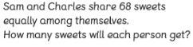
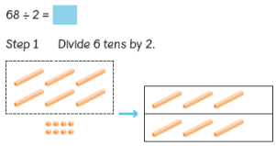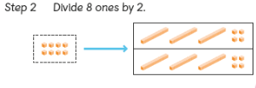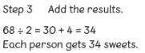

Pupils should be introduced to the chunking method for division by subtracting chunks – a multiple of the divisor. At this stage, pupils should be dividing a two-digit number by a one-digit number.

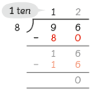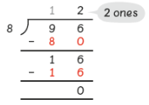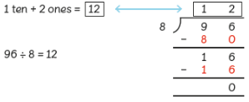

Pupils could also be shown the short division method and see how the two methods link.
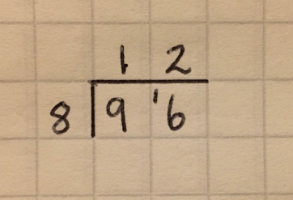

Continue to use bar modelling when problem solving.
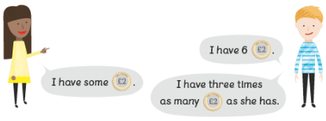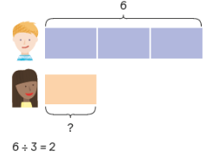

Division – Year 4
National Curriculum Key Skills | Key vocabulary
- Recall and use multiplication and division facts for up to 12 x 12  - Children practise to become fluent in the formal method of short division with exact answers when dividing three-digit numbers by a one-digit number  - Solve two-step problems in contexts, choosing the appropriate operation, working increasingly with harder numbers. | group  groups of  equal  lots of  divide  divided by  divided into  division  chunking | grouping  left  left over  inverse  short division  remainder  tens  ones  hundreds

Pupils to continue dividing two-digit numbers by a one digit number and also three-digit numbers by a one digit number, including with remainders.

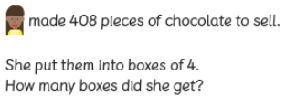
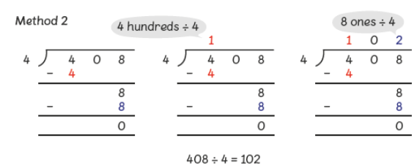

Pupils must also practise using the short method for division with up to three-digit numbers.
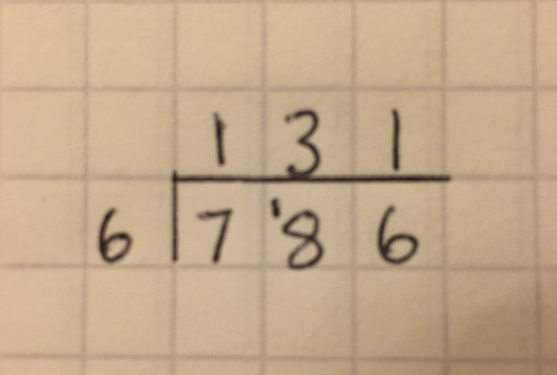

Division – Year 5
National Curriculum Key Skills | Key vocabulary
- Divide numbers up to 4 digits by a one-digit number using the formal written method of short division and interpret remainders appropriately for the context  - Multiply and divide whole numbers and those involving decimals by 10, 100 and 1000 | group  groups of  equal  lots of  divide  divided by  divided into  division  chunking | grouping  left  left over  inverse  short division  remainder  tens  ones  hundreds  thousands

Pupils will use the chunking method for dividing three and four-digit numbers by a one-digit number.
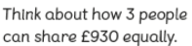
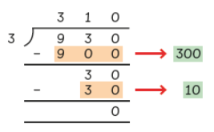

Pupils must also use the formal short method for division, including with remainders.

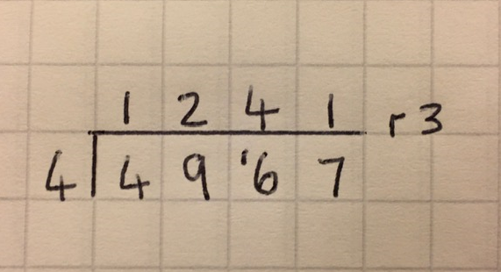

Division – Year 6

National Curriculum Key Skills | Key vocabulary
- Divide numbers up to 4 digits by a two-digit whole number using the formal written method of long division, and interpret remainders as whole number remainders, fractions, or by rounding, as appropriate for the context  - Divide numbers up to 4 digits by a two-digit number using the formal written method of short division where appropriate, interpreting remainders according to the context | group  groups of  equal  lots of  divide  divided by  divided into  division  chunking | grouping  left  left over  inverse  short division  remainder  tens  ones  hundreds  thousands  decimal  fraction
Pupils should continue to use the short method for division but with numbers to at least 4 digits, and understand how to express remainders as fractions, decimals, whole number remainders, or rounded numbers.
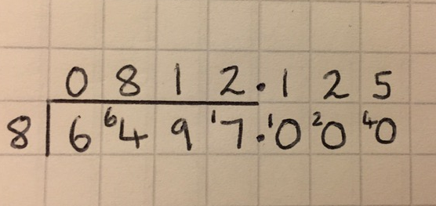

Pupils can use either of the methods below when dividing by two-digit numbers.
The chunking method:
Pupils must subtract the largest chunks possible. In the example below, discourage pupils from subtracting 10x36 and then another 10x36.

Pupils should be encouraged to write a ‘Useful Box’ e.g. 1x36=36, 2x36=72, 5x36=180, 10x36=360
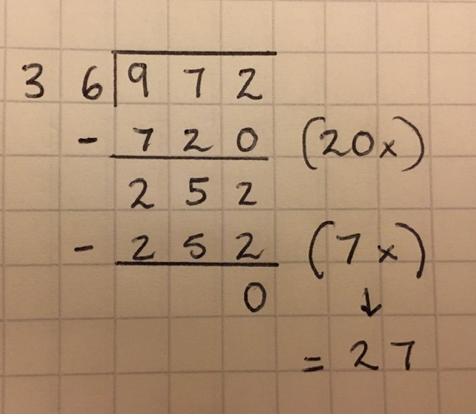

Short division:
Pupils can also use the short method for division when dividing by a two-digit number. Encourage pupils to write a ‘Useful Box’.
