How to choose a book...
“At Carlton Central Junior School we use the 5 finger rule!”
- Take a book 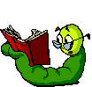from the colour band the teacher has chosen for you.
- Read the first paragraph out aloud to yourself, counting the mistakes you make on one hand.
- If you make more than 5 mistakes or don’t know more than 5 words, it’s too hard – choose again.

If you are stuck – ASK FOR HELP!

