Multiplication – Year 3
National Curriculum Key Skills | Key vocabulary
- Recall and use multiplication facts for the 2, 3, 4, 5, 8 and 10 multiplication tables and multiply multiples of 10.  - Write and calculate mathematical statements for multiplication using the multiplication tables that they know, including for two-digit numbers times one-digit numbers, using mental and progressing to formal written methods  - Solve problems, including missing number problems | groups of  lots of  times  multiply  altogether  repeated addition  expanded | column  multiple  tens  ones  product  array  regroup

Begin by using arrays to show one-digit x one-digit:

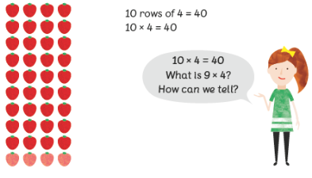

Multiply multiples of 10 by using known times tables facts. Use manipulatives to show.
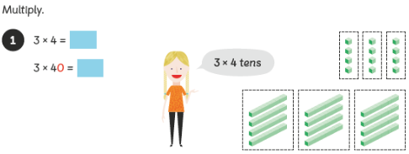

Multiply two-digit number by one-digit number using the expanded column method first then move on to the compact method.

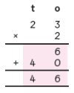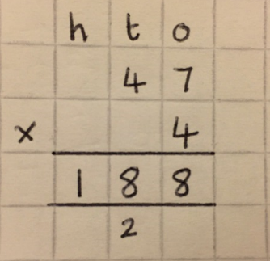
When regrouping, write directly below the next column.

Continue to use visual bars when solving multiplication problems.

Multiplication – Year 4
National Curriculum Key Skills | Key vocabulary
- Recall multiplication and division facts for multiplication tables up  to 12 × 12  - Multiply two-digit and three-digit numbers by a one-digit  number using formal written layout  - Solve problems involving multiplying | groups of  lots of  times  multiply  altogether  repeated addition  expanded | column  multiple  hundreds  tens  ones  product  array  regroup

Pupils should continue to develop their knowledge and understanding of multiplying by a single digit, using the formal written method of compact multiplication (short multiplication).

Recap expanded method from Year 3 but then move onto the compact method including regrouping. Pupils will multiply two and three-digit numbers by a one-digit number.
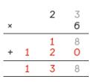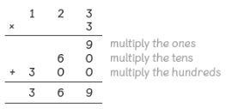

Useplace value counters to show the same calculation.
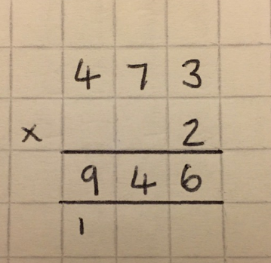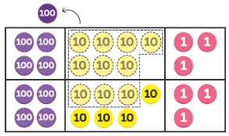
When regrouping, the digit is placed directly below the next column.

Continue to use visual bars when solving multiplication problems.

Multiplication – Year 5
National Curriculum Key Skills | Key vocabulary
- Identify multiples and factors, including finding all factor pairs of a number, and common factors of two numbers  - Multiply numbers up to 4 digits by a one- or two-digit number using a formal written method, including long multiplication for two-digit numbers  - Multiply numbers mentally drawing upon known facts  - Multiply whole numbers and those involving decimals by 10, 100 and 1000 | groups of  lots of  times  multiply  altogether  repeated addition  expanded | column  multiple  thousands  hundreds  tens  ones  product  array  regroup

Pupils will continue to use the short method for multiplication to multiply two, three and four-digit numbers by a one-digit number.
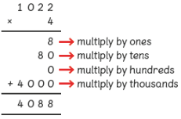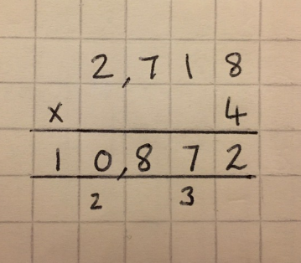
Recap expanded method first. Then move on to the compact method using regrouping.

Pupils then move onto using the long method for multiplication to multiply two two-digit numbers.
Pupils must write a zero as a place holder on the second row in the ones column.
. 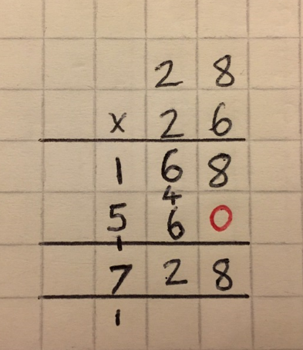

When regrouping, the digit is placed directly below the next column.

Multiplication – Year 6
National Curriculum Key Skills | Key vocabulary
- Multiply multi-digit numbers up to 4 digits by a two-digit whole number using the formal written method of long multiplication  - Solve multi-step problems in contexts, deciding which operations and methods to use and why | groups of  lots of  times  multiply  altogether  repeated addition | column  multiple  thousands  hundreds  tens  ones  product  regroup  decimal  tenths  hundredths

Pupils will continue to perform short and long multiplication including three and four-digit numbers multiplied by a two-digit number.
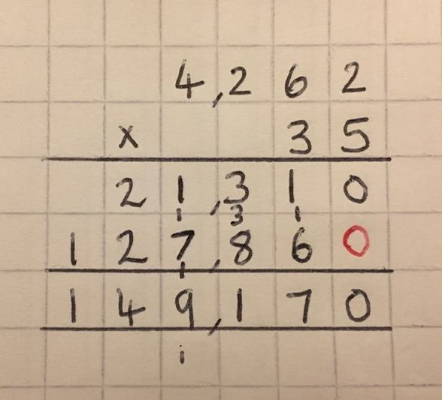
When regrouping, the digit is placed directly below the next column.

Pupils will move on to the multiplication of numbers with up to two decimal places by a one-digit number.
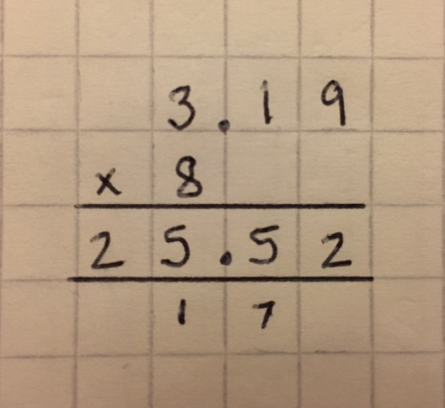
Ensure pupils line the digits and decimal points up correctly.

Pupils should have further experience calculating with these methods when using money and measures.

