Subtraction – Year 3
National Curriculum Key Skills | Key vocabulary
- Subtract 2-digit numbers mentally, including those exceeding 100  - Subtract a 3-digit number and ones mentally  (e.g. 127 - 7 )  - Subtract a 3-digit number and tens mentally  (e.g. 239 - 50 )  - Subtract a 3-digit number and hundreds mentally  (e.g. 635 - 400 )  - Continue to practise a wide range of mental subtraction strategies, i.e. number bonds, subtracting the nearest multiple of 10,100,1000 and adjusting, using near doubles, partitioning and recombining  - Estimate and use the inverse to check answers  - Solve problems, including missing number problems, using number facts, place value and more complex subtraction. | hundreds  tens  ones  expanded  compact  column  rename regroup  subtraction | digits  difference  minus  take away  less than

When subtracting 1 digit numbers and multiples of 10 from 3 digit numbers, pupils should use mental strategies (counting on or back) and Base 10 for support.

- Introduce the compact column method using manipulatives first. Start subtracting the ones first.
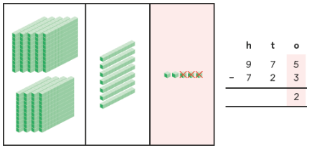

- Then introduce subtraction with regrouping using the compact method with manipulatives first. Show the process of regrouping using the column method so that pupils can relate the 'crossing out' to regrouping. It is important here that pupils understand why they are crossing out the tens column.
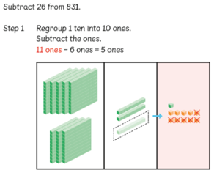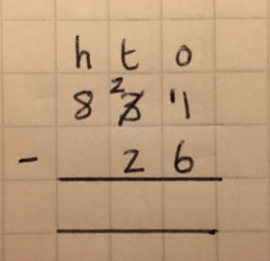
Continue to use bar modelling as a visual model to solve problems involving subtraction.
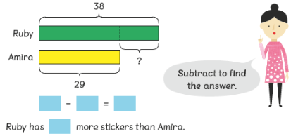
Subtraction – Year 4
National Curriculum Key Skills | Key vocabulary
- Subtract by counting on where the numbers are close together or where they are near to multiples of 10 or 100  - Subtract numbers with up to 4 digits using the formal written methods of columnar addition and subtraction where appropriate  - Estimate and use inverse operations to check answers to a calculation  - Solve addition and subtraction two-step problems in contexts, deciding which operations and methods to use and why. | thousands  hundreds  tens  ones  compact  column  rename regroup  subtraction | digits  difference  minus  take away  less than

- Use concrete materials (place value counters) first then link this with the compact column method including regrouping.

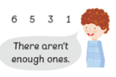
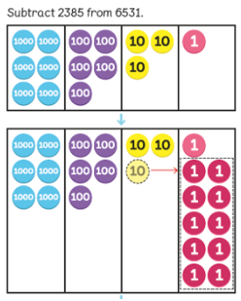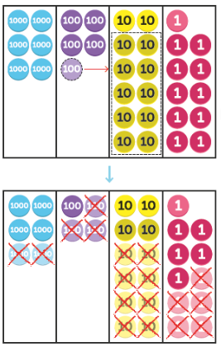
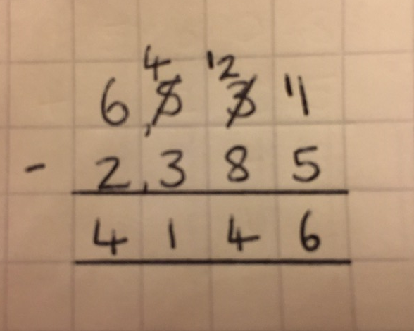
- Continue to use the bar model when solving problems.
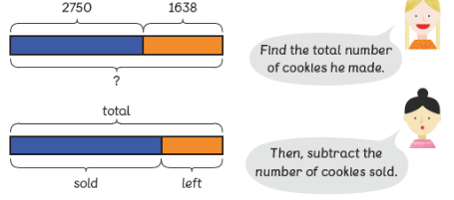

Subtraction – Year 5
National Curriculum Key Skills | Key vocabulary
- Subtract whole numbers with more than 4 digits, including using formal written methods (columnar subtraction)  - Subtract numbers mentally with increasingly large numbers  - Use rounding to check answers to calculations and determine, in the context of a problem, levels of accuracy  - Solve addition and subtraction multi-step problems in contexts, deciding which operations and methods to use and why. | ten thousands  thousands  hundreds  tens  ones  compact  column  subtract  minus | digits  decimal  decimal point  tenths  hundredths  thousandths  rename  regroup

Pupils will subtract numbers with more than four digits but within 1,000,000.
- Use the standard column method, including regrouping. Continue to use pictorial representations.
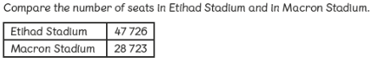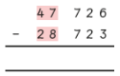
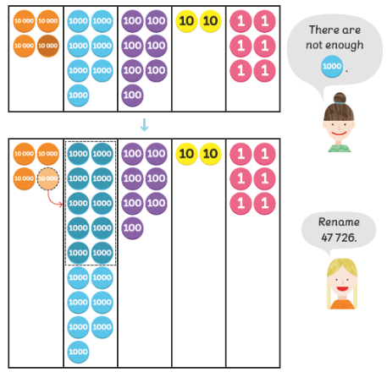
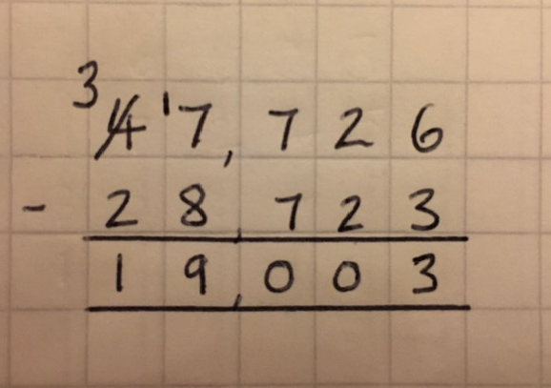
- When adding decimal numbers, use place value counters first.
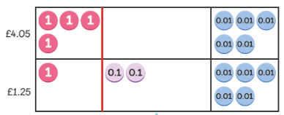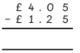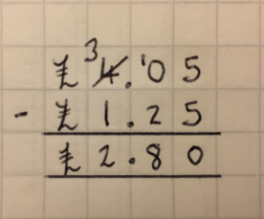
Pupils must ensure that the digits are in the correct columns and that the decimal points line up. Empty decimal places can be filled with a zero to aid understanding. Continue to use bar models as representations and when solving problems.
Subtraction – Year 6
National Curriculum Key Skills | Key vocabulary
- Perform mental calculations, including with mixed operations and large numbers, using and practising a range of mental strategies  - Solve multi-step problems in contexts, deciding which operations and methods to use and why  - Use estimation to check answers to calculations and determine, in the context of the problem, levels of accuracy | ten thousands  thousands  hundreds  tens  ones  compact  column subtract  minus  take away | digits  decimal  decimal point  tenths  hundredths  thousandths  rename  regroup

Pupils will continue to subtract with increasingly larger and more complex numbers and decimal values.

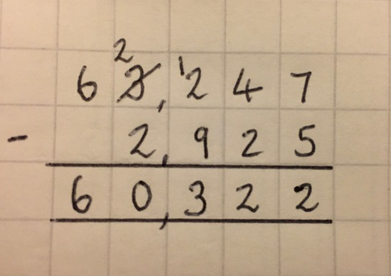
- Tenths, hundredths and thousandths should be correctly aligned, with the decimal point lined up vertically including in the answer row.

- Zeros will be added into any empty decimal places, to show there is no value to subtract.

