PSHRE Long term plan: Puzzles and their contents
September 2026

Year 3

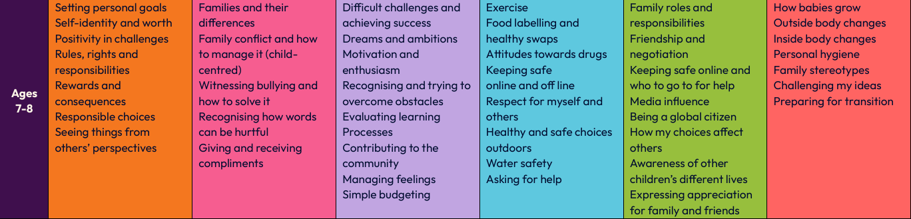

Year 4

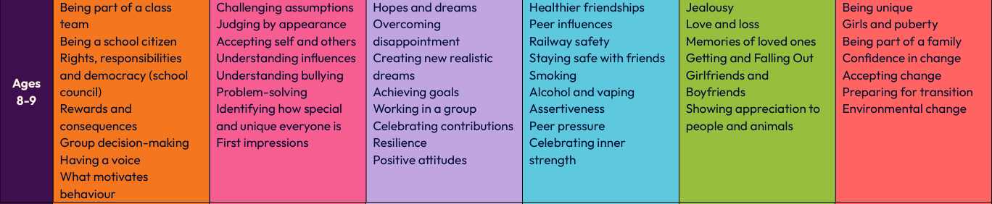
Year 5
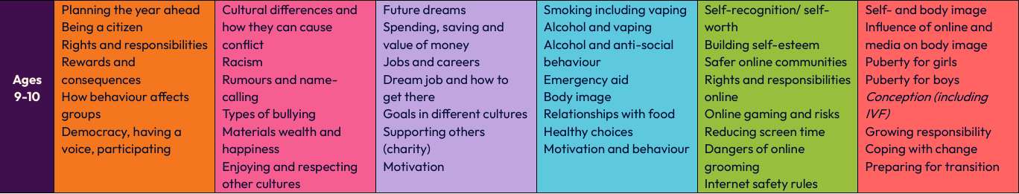

Year 6
